# Cloud Computing - Hands-On Exercise

I created a Microsoft Azure subscription.

In this subscription I create a Microsoft Azure Storage resource in West US region. This storage resource is also mirrored in East US.

Using Visual Studio, I wrote a program to use the Azure Storage library to access the storage APIs. I am using the API to create a storage container and write a blob to this container. These are the Blob storage APIs. Azure storage client also exposes Table Storage and Queue access APIs.

In the screen shots below, you will see that I create a Command Line Interface, to take an input string from user. This string text is written to Blob storage as a text blob.

Microsoft Azure also provides Azure Storage Explorer to see the contents of your Storage Resource. In order to verify that the upload has succeeded, I used this tool to look at the contents of my container and found that my blob is successfully uploaded.

Created Storage Account in Azure:

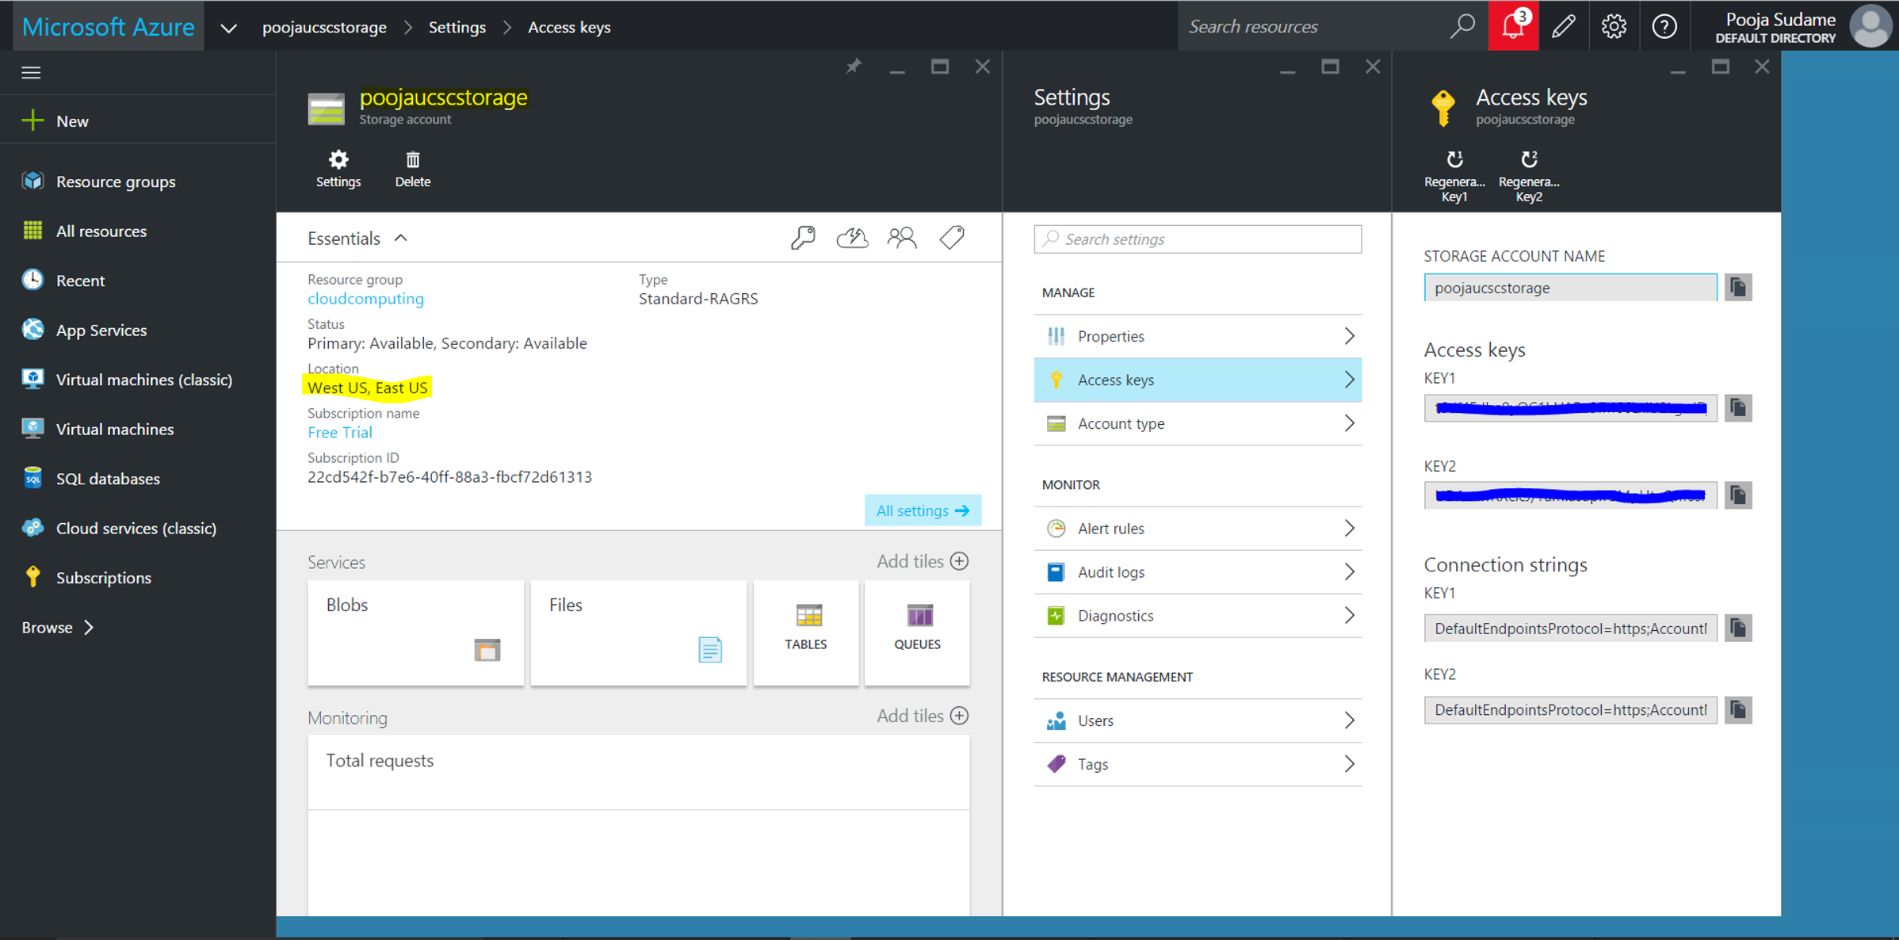

Program that accepts input from user and uploads to storage:

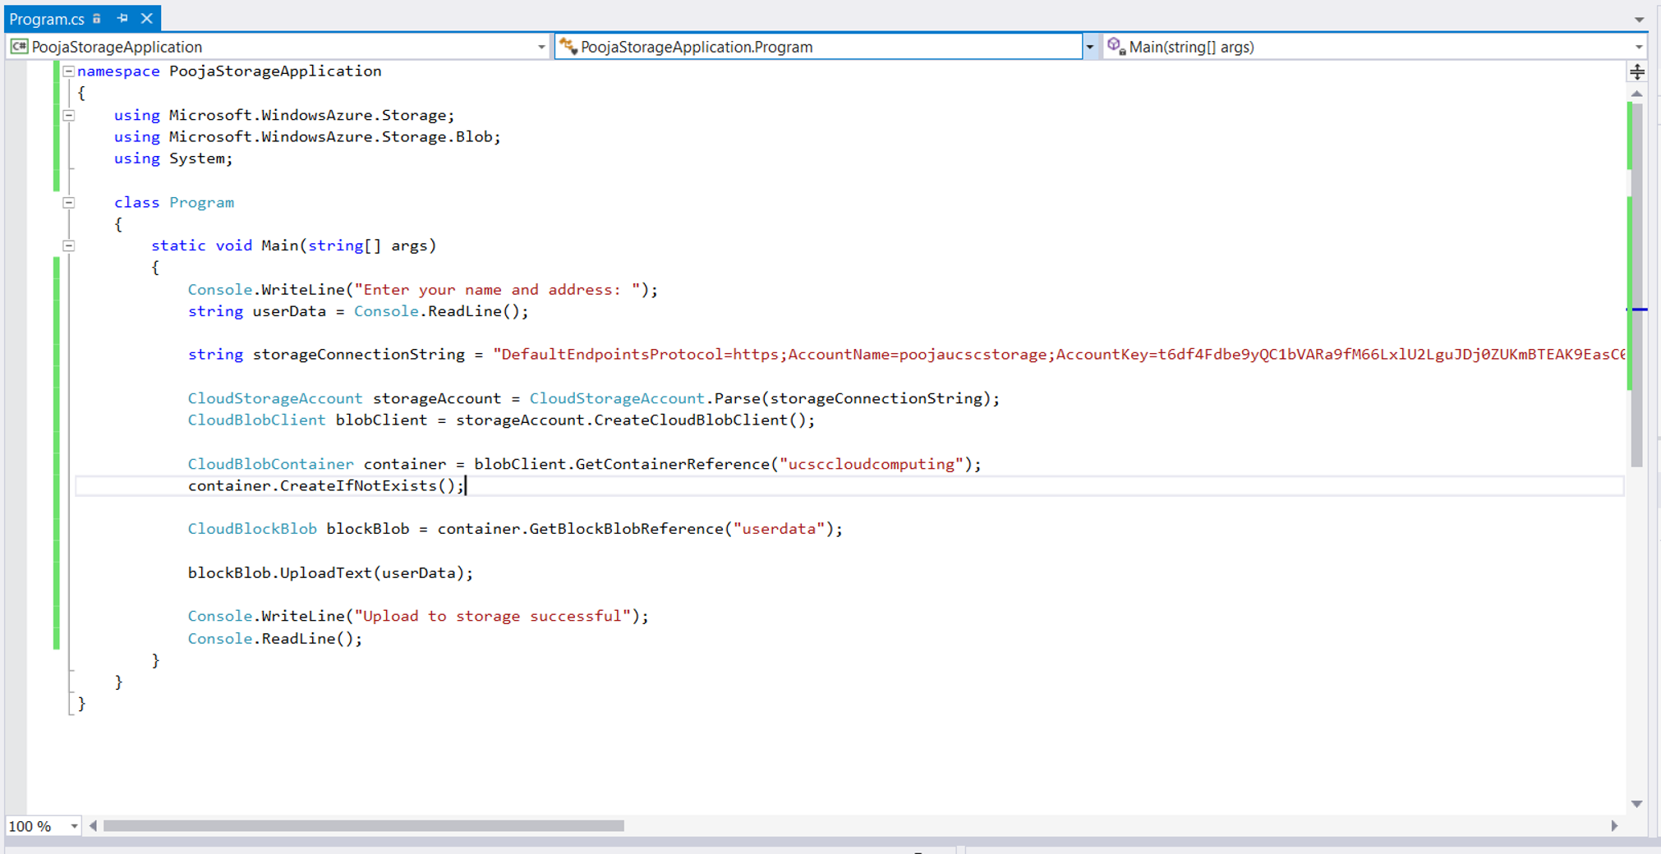

Program run that uploads user input to storage:

Machine generated alternative text:
• file:///c:/users/pooja/documents/visual studio 
Enter your name and address: 
John Smith 123 Augustine Drive, Santa Clara, California. 
Upload to storage successful 

Using Azure Storage Explorer I can see the container 'ucsccloudcomputing' created and the blob 'userdata' present in it.

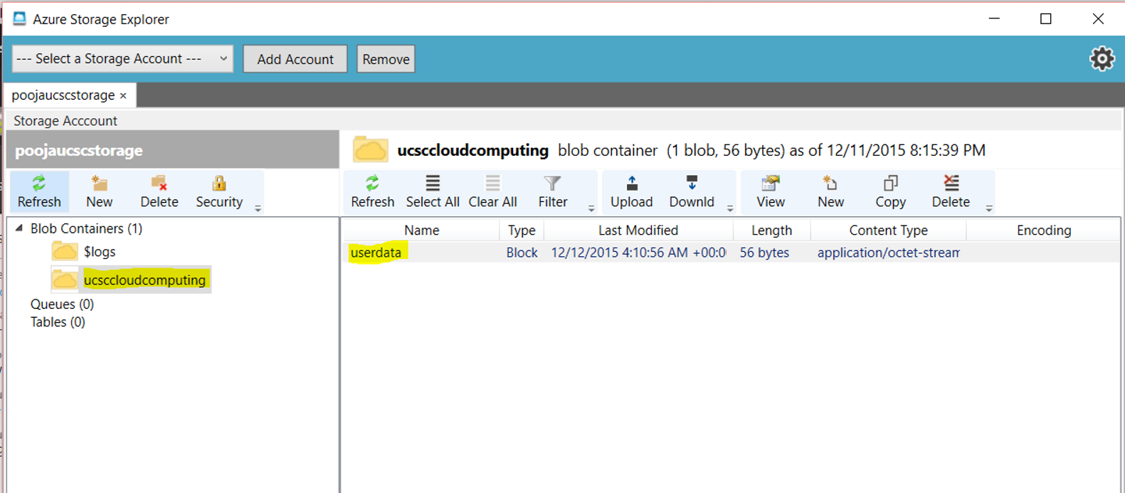

The blob contents are also as entered by the user:

